**Webotech (Website for a web developing company featuring their products, services, team, their location and other basic functionalities)**

**HomePage:**

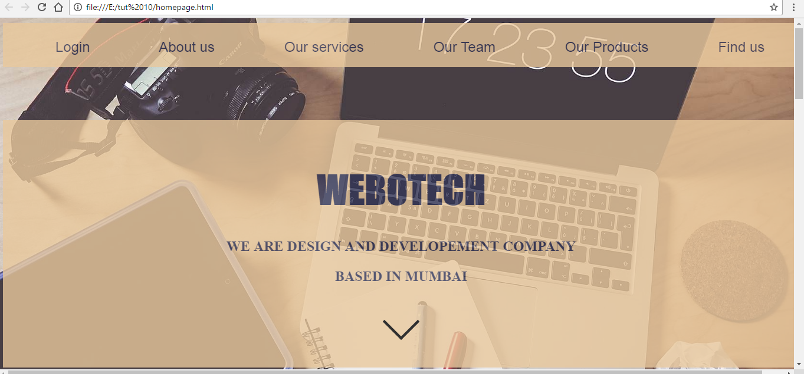

**SignUp:**

**(All validations at clientside are using javascript including calculation of hash using SHA1 library from cdnjs, and storing hashed password into database using php)**

1. **Student should design the authentication system such that the end user will be encouraged to select strong password by showing his selected password strength on registration page.**

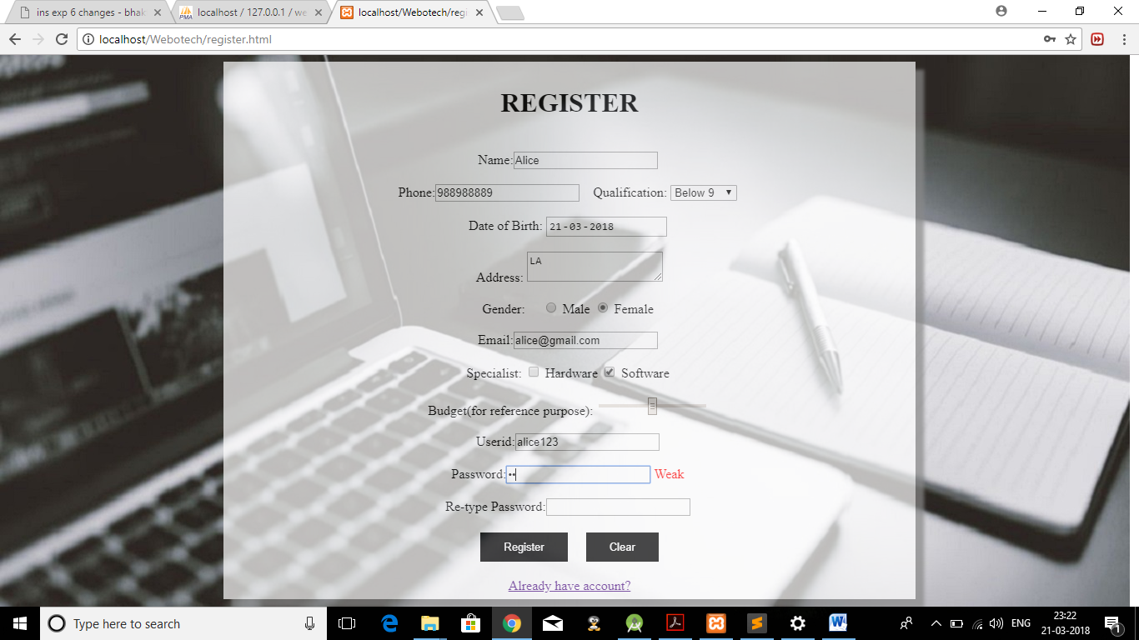

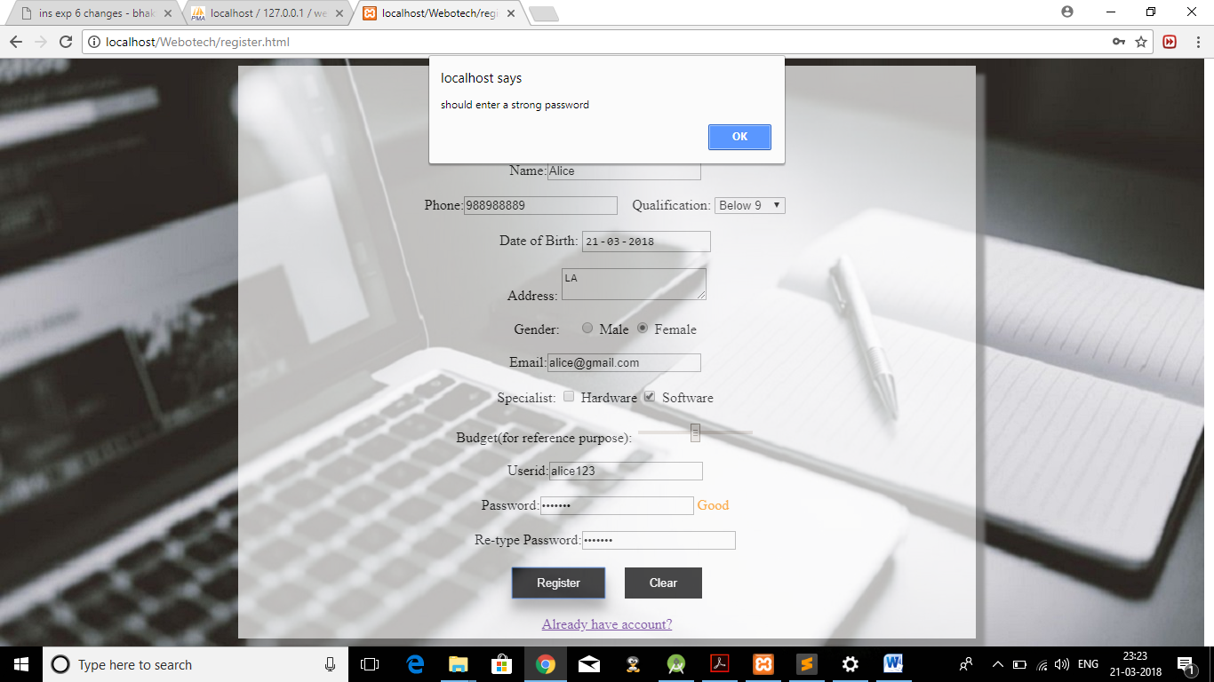

**Strong password(User registered on 21-3-2018)**

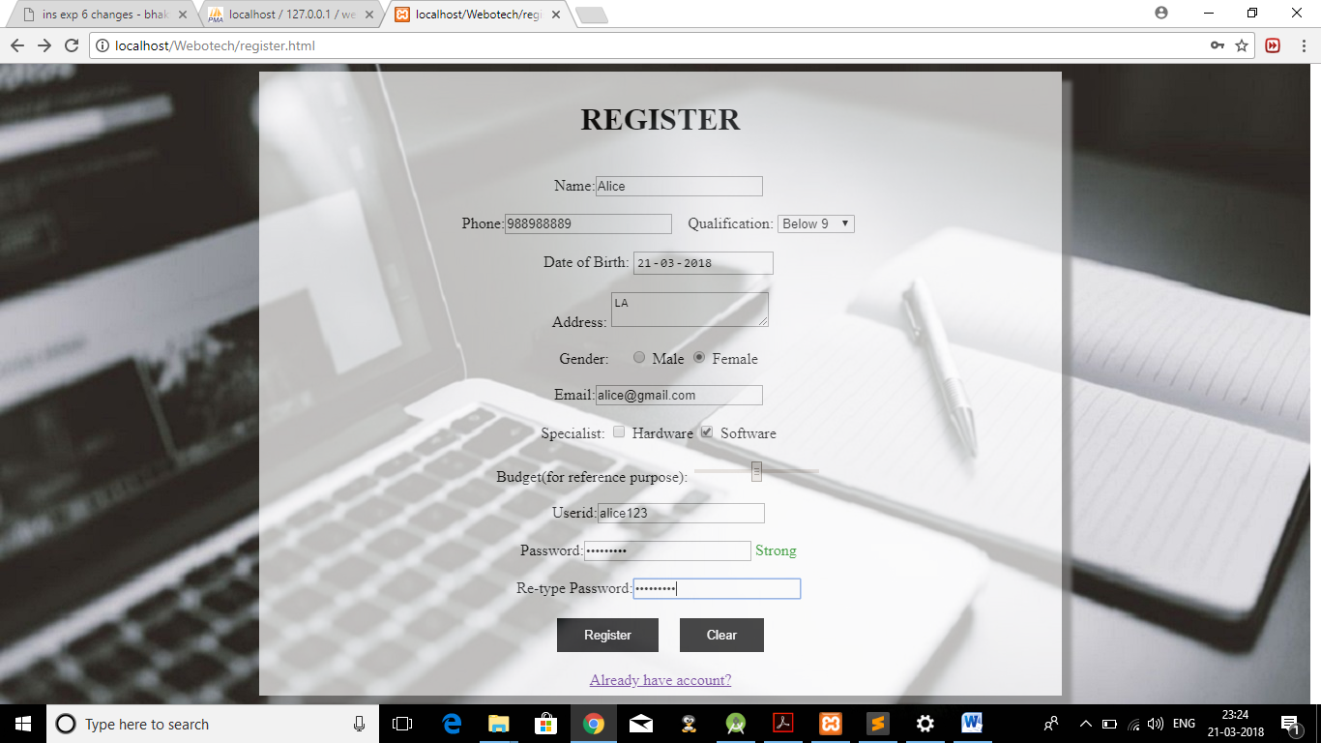

**Login:**

1. **The end user should be prompted to change his password after certain period of time.**

**Changed the date from 21-3-2018 to 22-4-2018:**

**It prompts the user that password has expired and redirects him to change the password where, password and his current timestamp gets updated:**

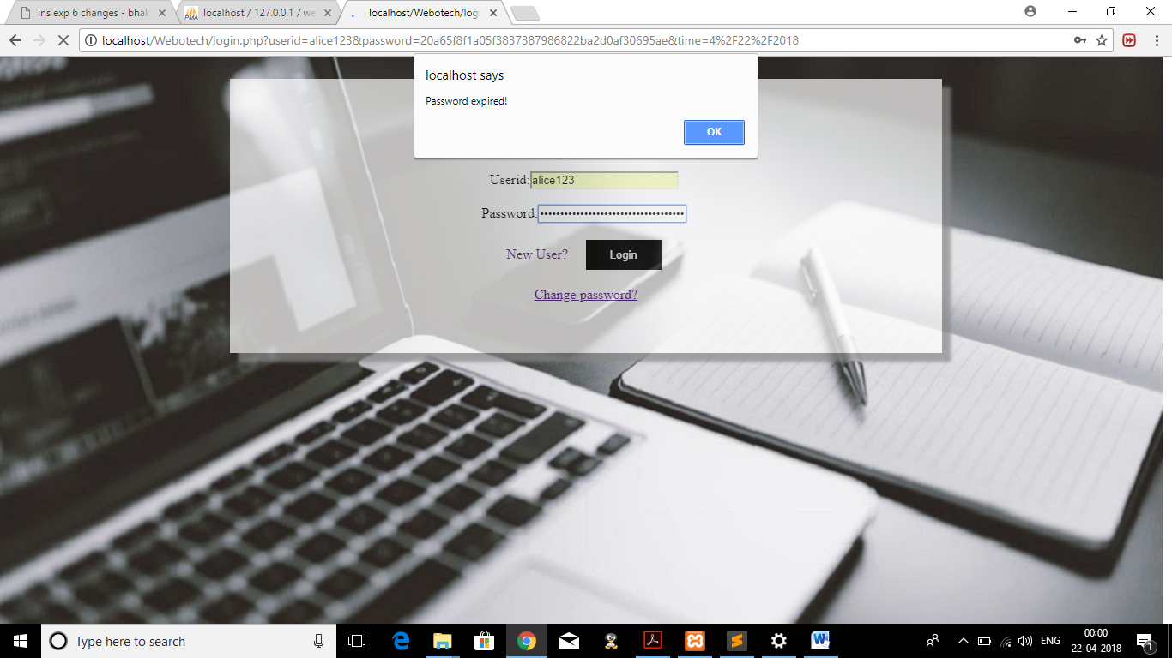

**Changing password:**

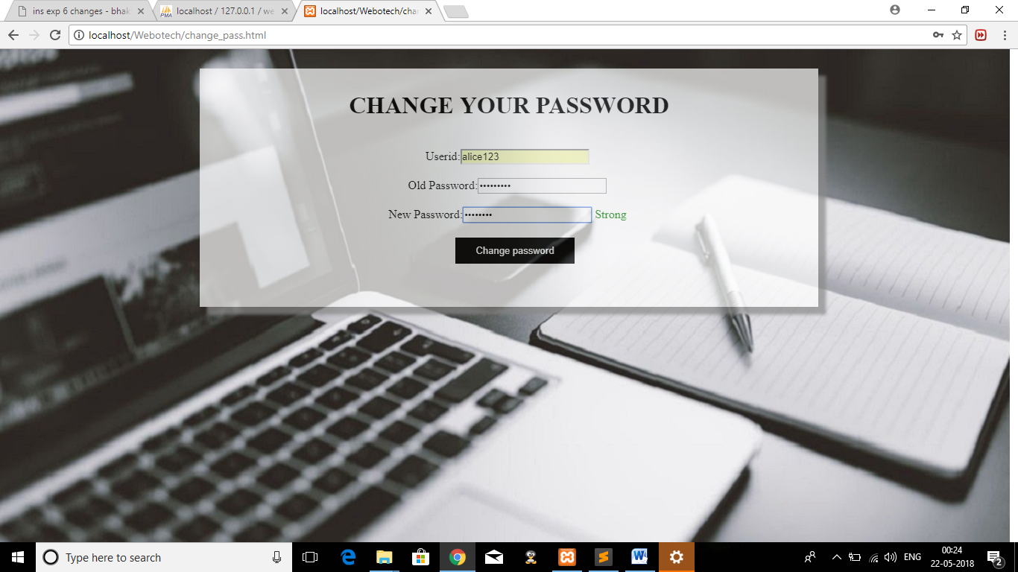

**Updated data:**

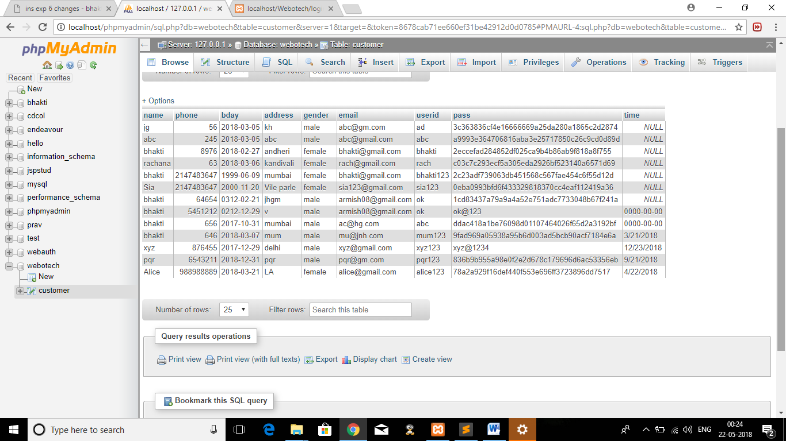

1. **Student should save username and hashed password pair in database, which can be used for authentication purpose.**

**Registration form:**



**Database storing the hash value of password(i.e calculated on client-side):**

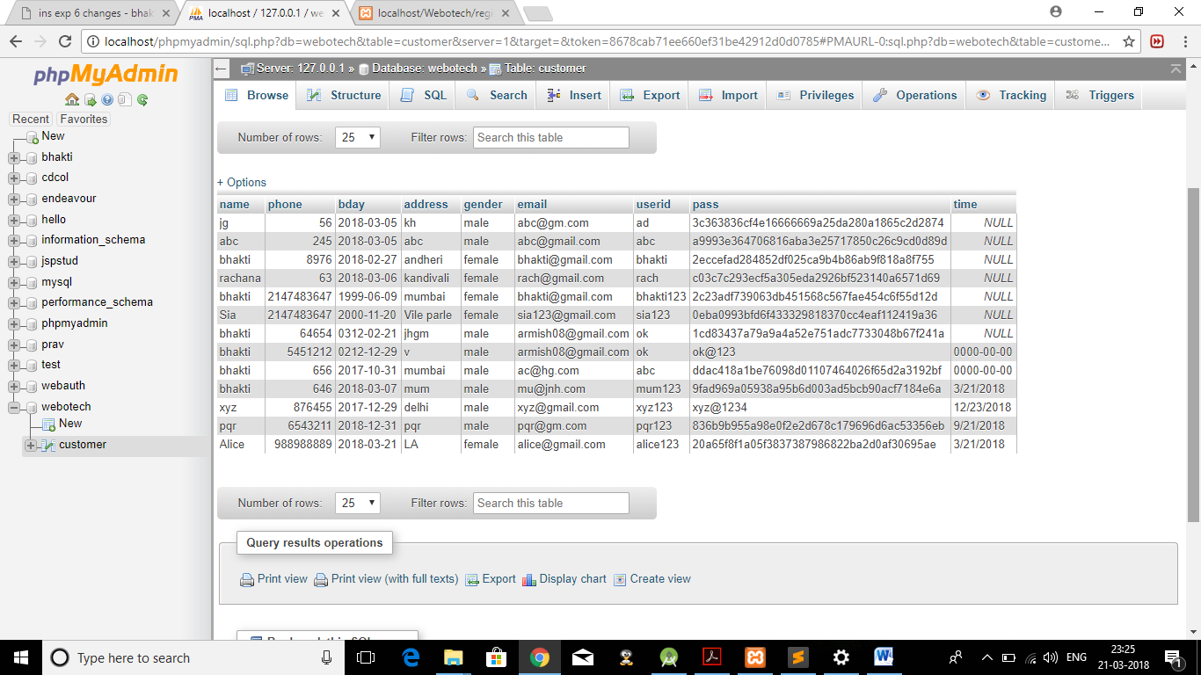



**Log in with new userid password:**

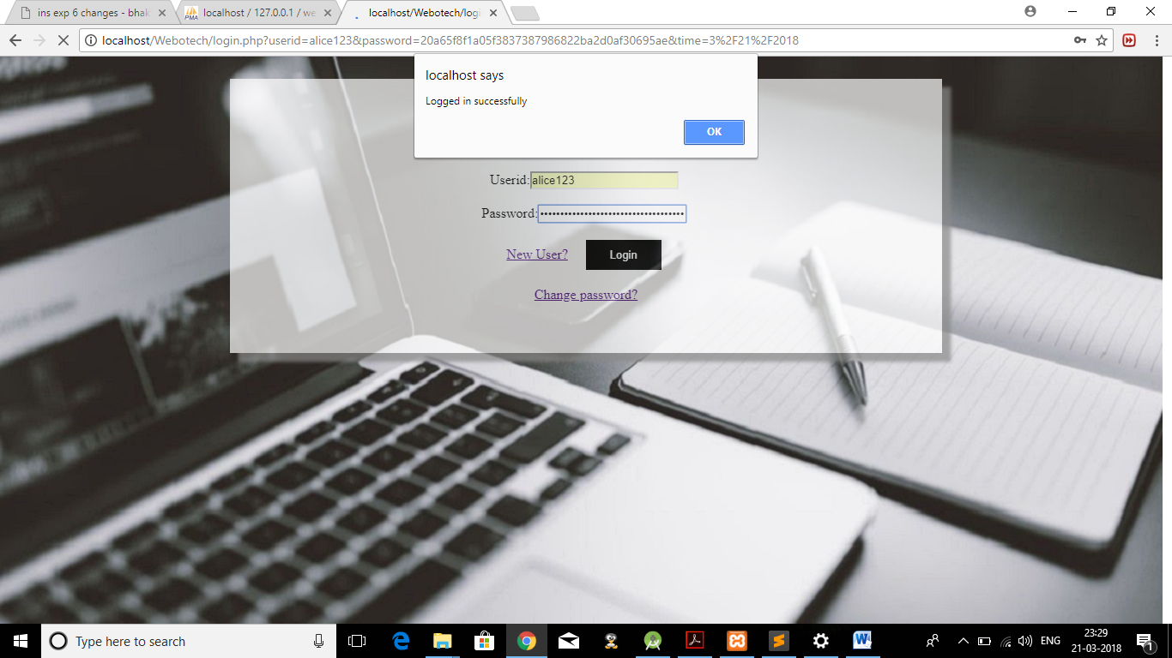

**Verifies the user using hash value and redirects to homepage when Login successful:**



**All the below the the animations using jquery.**

**Aboutus:**

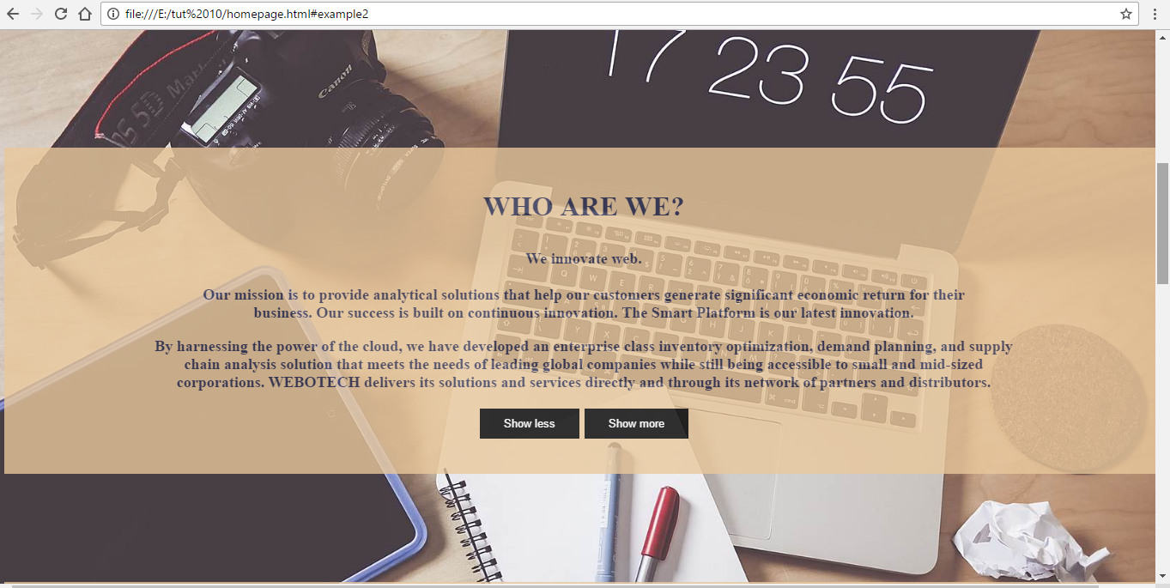

**Our Services:**

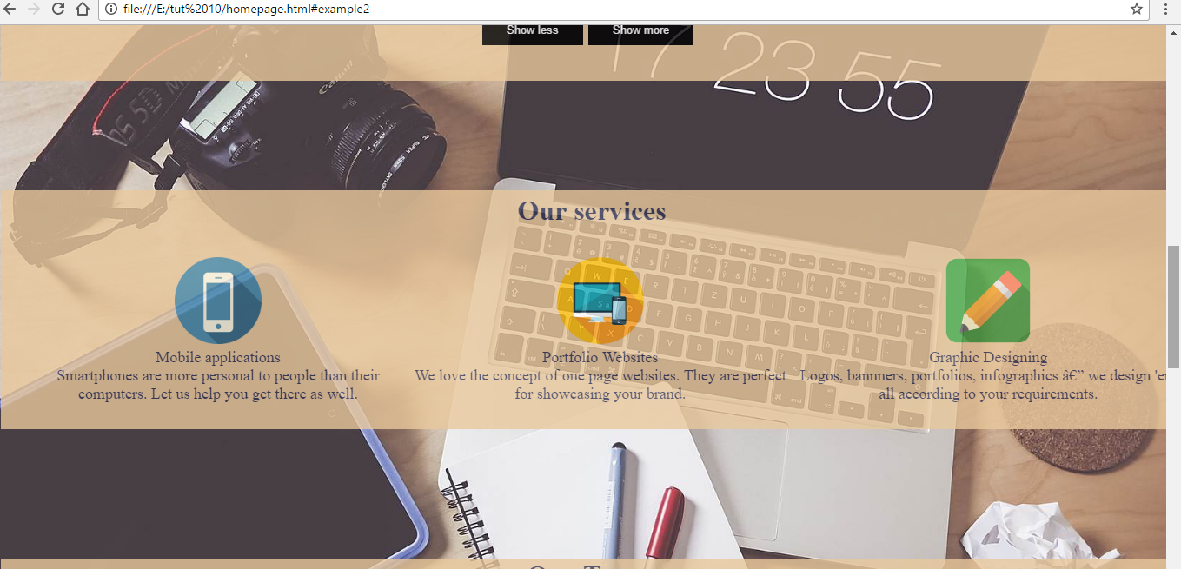

**Our Team:**





**Our Products:**

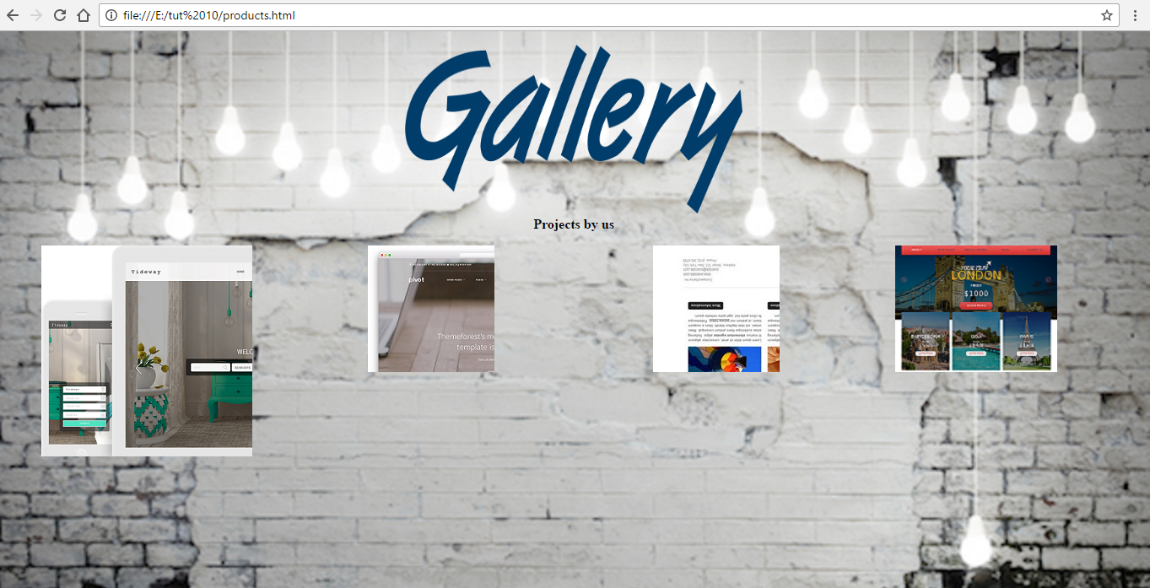

**Find us:**

